Large Sample Splitter
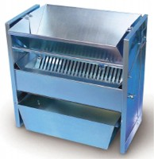 | Large Capacity Sample Splitter.  Code: 23-3425  Attributes: Description = Sample Splitter, Material Pans = Two included; 25 -3/4” l. x 9” w. x 6-1/2” h. (654 x 22 9 x 165 mm).  Standards:

