Versa-Loader
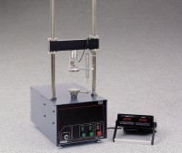 | Unconfined Compression Test Digital Readout Set, English 220 vAC  Code: 27-1121/01  Attributes: Weight, lbs = 12, Description = Unconfined Compression Test Digital Readout Set, English 220 vAC  Standards: ASTM D2166, AASHTO T208

Unconfined Compression Test Digital Readout Set, English 110 vAC
Code: 27-1121/02
Attributes: Description = Unconfined Compression Test Digital Readout Set, English 110 vAC
Standards: ASTM D2166, AASHTO T208

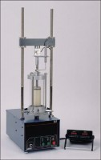 | Versa-Loader  Code: 25-3525/02  Attributes: Maximum Load, tsf = 10,000, Description = Versa-Loader  Standards: ASTM D1883, ASTM D2850, AASHTO T193, AASHTO T296, AASHTO T208

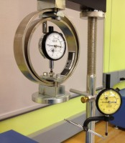 | Unconfined Compression Assembly Only  Code: 25-3999  Attributes: Weight, lbs = 6, Description = Unconfined Compression Assembly Only  Standards: ASTM D2166, AASHTO T208

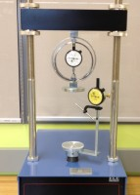 | Unconfined Compression Test Accessory Set, English  Code: 25-3997  Attributes: Weight, lbs = 9, Description = Unconfined Compression Test Accessory Set, English  Standards: ASTM D2166, AASHTO T208

Unconfined Compression Test Accessory Set, Metric
Code: 25-3998
Attributes: Weight, lbs = 9, Description = Unconfined Compression Test Accessory Set, Metric
Standards: ASTM D2166, AASHTO T208

