Modular Pressure Panel System
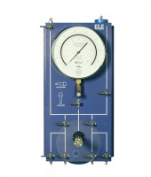 | Universal Pump and Pressure Indicating Panel 1700Kpa.  Code: 26-1880  Attributes: Description = Universal Pump and Pressure Indicating Panel 1700Kpa, Weight, kg = 12  Standards:

 | Pressure Gauge 1700Kpa (250Psi) 250mm Diameter.  Code: 26-1865/10  Attributes: Description = Pressure Gauge 1700Kpa (250Psi) 250mm Diameter., Weight, kg = 2.5  Standards:

