Digital Load and Displacement Readout
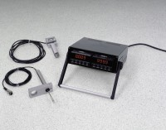 | 2 Channel Digital Readout, English  Code: 27-1108/01  Attributes: Rated Power = 220vAC, 50/60Hz, 1ø., Description = 2 Channel Digital Readout, English  Standards:

2 Channel Digital Readout, English
Code: 27-1108/02
Attributes: Rated Power = 110vAC, 50/60Hz, 1ø., Description = 2 Channel Digital Readout, English
Standards:

2 Channel Digital Readout, Metric
Code: 27-1109/02
Attributes: Rated Power = 110vAC, 50/60Hz, 1ø., Description = 2 Channel Digital Readout, Metric
Standards:

