Flow meters
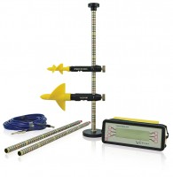 | Miniature Current Flow Meter Wading Set for Velocities 0.03 to 5 M/S.  Code: 520-265  Attributes: Description = Miniature Current Flow Meter, Velocity Range = 0.03 - 5 m/s  Standards:

Large Current Flow Meter Wading Set for Velocities 0.03 to 10 M/S.
Code: 520-260
Attributes: Description = Large Current Flow Meter, Velocity Range = 0.03 - 10 m/s
Standards:

 | Pc Download Cable for Current Flow Meter.  Code: 520-261  Attributes: Description = PC Download Cable  Standards:

