Beakers and Covers
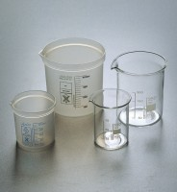 | Beaker - 100 ml  Code: 82-0120  Attributes: Description = Beaker, Capacity, ml = 100  Standards:

Beaker - 250 ml
Code: 82-0140
Attributes: Description = Beaker, Capacity, ml = 250
Standards:

Beaker - 600 ml
Code: 82-0200
Attributes: Description = Beaker, Capacity, ml = 600
Standards:

Beaker - 1000 ml
Code: 82-0220
Attributes: Description = Beaker, Capacity, ml = 1,000
Standards:

Beaker Cover
Code: 82-0260
Attributes: Description = Beaker Cover - 100 mm, Nominal Diameter, mm = 100 mm
Standards:

