Standard Compaction Hammer
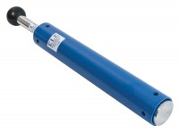 | ASTM Compaction Rammer 2.5Kg.  Code: 24-9063  Attributes: Description = Proctor compaction rammer  Standards: ASTM D558, ASTM D559, ASTM D560, ASTM D698, AASHTO T99, AASHTO T134, AASHTO T135, AASHTO T136

