Concrete Permeability Test System (Porouscope)
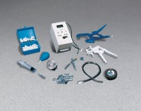 | Concrete Permeability Test System  Code: 35-4050  Attributes: Rated Power = Standard 9V battery., Description = Concrete Permeability Test System  Standards:

