Vibrating Table
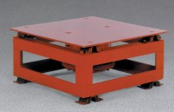 | Vibrating Table  Code: 34-6222/02  Attributes: Amplitude = Variable from 0 to 1/16” (1.58 mm) linear vibration., Description = Vibrating Table  Standards:

