Portable Slump Test Set
 | Portable Slump Test Set  Code: EL3010E  Attributes: Weight, lbs = 16.9, Description = Portable Slump Test Set  Standards: ASTM C143, ASTM C192, AASHTO T23, AASHTO T119, ASTM T126

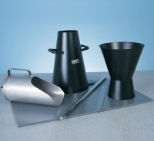 | Slump Cone Funnel  Code: 34-0180  Attributes: Description = Slump Cone Funnel, Weight, kg = 1.3 kg, Base Dimensions l x w x h, ” = 208.59  Standards: ASTM C143, ASTM C192, AASHTO T23, AASHTO T119, ASTM T126

