ASTM/Modified Proctor compaction
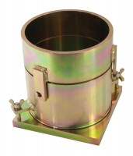 | ASTM Compaction Mould 152mm.  Code: 24-9066  Attributes: Description = ASTM/Modified Proctor compaction mould, Construction = Steel  Standards: ASTM D698, ASTM D1557, AASHTO T99, AASHTO T180

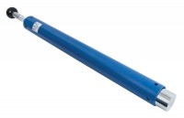 | ASTM Compaction Rammer 4.5Kg.  Code: 24-9070  Attributes: Description = ASTM/Modified Proctor rammer, Hammer Weight, lbs = 10  Standards: ASTM D1557, AASHTO T180

