Load Measurement
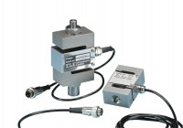 | 50kN S-type Load Cell  Code: 27-1559  Attributes: Description = S-type load cell - 50 kN, Value of CBR % = ALL, Environmental Protection = IP65, Force Capacity, kN = 50  Standards: EN 12697-34

