Torvane Shear Device
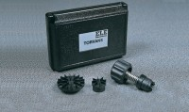 | Pocket Shearmeter with 3 Vanes 0 to 1Kgf/Cm2 X 0.5Kgf/Cm2.  Code: 26-2261  Attributes: Description = Torvane Shear Device, Dial Scale = 1 kg/sq. cm (tons/sq. ft.) x 0.05 subdivisions.  Standards:

 | Sensitive Vane  Code: 26-2261/10  Attributes: Dimensions w x d x h, ” = 45.78x45x15.24 mm, Description = Sensitive Vane  Standards:

Standard Vane
Code: 26-2261/12
Attributes: Weight, lbs = 0.02, Description = Standard Vane
Standards:

High-Capacity Vane
Code: 26-2261/14
Attributes: Dimensions w x d x h, ” = 30x30x24 mm, Description = High-Capacity Vane
Standards:

