BS EN Compression Machines
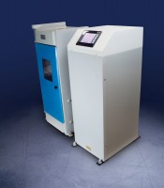 | ADR-Auto V2.0 2000 BS Compression Machine  Code: 36-4150/01  Attributes: Voltage Supply = 220-240 V 50 Hz, Force Capacity, kN = 2000, Maximum Ram Travel mm = 50  Standards: EN 12350-6, NF P18-411

ADR-Auto V2.0 2000 BS Compression Machine
Code: 36-4150/06
Attributes: Voltage Supply = 220-240 V 60 Hz, Force Capacity, kN = 2000, Maximum Ram Travel mm = 50
Standards: EN 12350-6

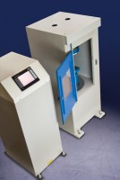 | ADR-Auto V2.0 3000 BS EN Compression Machine  Code: 36-4165/06  Attributes: Voltage Supply = 220-240 V 60 Hz, Force Capacity, kN = 3000, Maximum Ram Travel mm = 50  Standards: EN 12350-6

ADR-Auto V2.0 3000 BS EN Compression Machine
Code: 36-4165/01
Attributes: Voltage Supply = 220-240 V 50Hz, Force Capacity, kN = 3000, Maximum Ram Travel mm = 50
Standards: EN 12350-6, NF P18-411

