Load frames
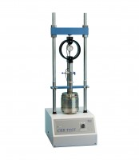 | Cbr-Test 50 Machine 50kN Capacity BS and ASTM Supplied with Stabilising Bar.  Code: 24-9150/01  Attributes: Description = CBR-Test 50 Machine, CBR Penetration = Yes, Voltage Supply = 220-240 V 50 Hz, Power Supply = 220 V AC, 50 Hz, 1 ph  Standards: BS 1377, BS 1924, EN 13286-47, ASTM D1883, AASHTO T193

Cbr-Test 50 Machine 50kN Capacity BS and ASTM Supplied with Stabilising Bar.
Code: 24-9150/06
Attributes: Description = CBR-Test 50 Machine, CBR Penetration = Yes, Voltage Supply = 220-240 V 60Hz
Standards:

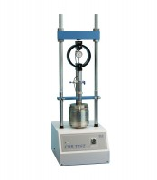 | CBR-Test 50 Machine 50 kN Capacity BS and ASTM Supplied with Stabilising Bar.  Code: 24-9150/02  Attributes: CBR Penetration = Yes, Voltage Supply = 110-120 V 60 Hz, Platen Travel, ” = 4.13, Description = CBR-Test 50 Machine  Standards: AASHTO T99, AASHTO T134, AASHTO T135, AASHTO T136, AASHTO T180

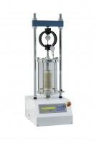 | MultiPlex 50 Load Frame  Code: 25-3700/01  Attributes: Description = MultiPlex 50 Load Frame, CBR Penetration = Yes, Unconfined Compression = Yes, Unconfined Compression = Yes, Voltage Supply = 220-240 V 50/60 Hz, Consolidated Undrained = -, Consolidated Drained = -, Power Supply = 220 - 240 V AC, 50 - 60 Hz, 1 ph, Marshall stability and flow = Yes  Standards: EN 12697-34, BS 598, BS 1377, BS 1924, ASTM D1883, EN 12697-23, EN 12697-24, EN 13286-47, AASHTO T193, ASTM D2850, ASTM D4767, AASHTO T296, AASHTO T297

