Soil Extruders
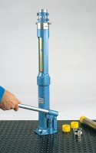 | 38mm Hand Operated Hydraulic Sample Extruder with Trimming Knife 38mm Split Former & Cutting Tool.  Code: 23-4090  Attributes: Description = Hydraulic Extruder  Standards: BS 1377-1

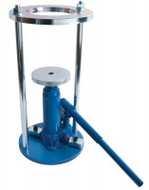 | Proctor/Core Cutter Extruder Frame and Hydraulic Jack. Extrudes 100mm/4 Inch Diameter Specimens  Code: 23-4200  Attributes: Description = Proctor /Core Cutter Extruder, Extrudes samples from = BS compaction mould<br>Proctor Mould<br>100 mm core cutter<br>Marshall mould  Standards: BS 1377-1

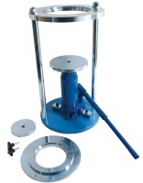 | Cbr/Core Cutter Extruder Frame and Hydraulic Jack Extrudes 150mm/6 Inch Diameter Specimens.  Code: 23-4250  Attributes: Description = CBR/Extruder, Extrudes samples from = BS CBR mould<br>ASTM CBR mould  Standards: BS 1377-1

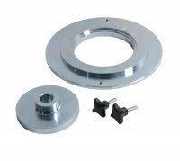 | Adaptor Plate for 23-4250 to Extrude 100mm/4 Inch Diameter and Marshall Specimens.  Code: 23-4300  Attributes: Description = Adaptor plate, Weight, kg = 2.2  Standards: BS 1377-1

