Stability Compaction Hammer
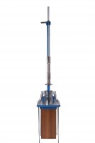 | Compaction Hammer  Code: 45-6460  Attributes: Description = Compaction Hammer, Drop, ” = 18  Standards: EN 12697-30, ASTM D6926, AASHTO T245

