Density of Coarse Aggregates Set
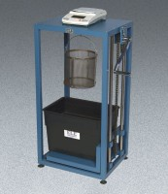 | Density of Coarse Aggregates Set  Code: 4204/02  Attributes: Rated Power = 110vAC, 50/60Hz, 1ø., Description = Density of Coarse Aggregates Set  Standards: ASTM C127, AASHTO T85

