BS/EN compaction test 4.5kg
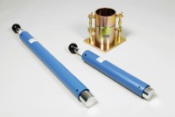 | BS Compaction Rammer 4.5Kg Wt.  Code: 24-9004  Attributes: Description = 4.5 kg compaction rammer, Finish = Corrosion resistant  Standards: BS 1377-4, BS 1924-2, EN 1997-2

Straight Edge 300mm.
Code: 24-9010
Attributes: Description = 300 mm straight edge
Standards: BS 1377-4, BS 1924-2, EN 1997-2, ASTM D698, ASTM D1557, AASHTO T99

