Constant Temperature Bath
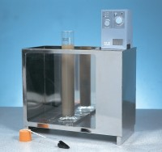 | Constant Temperature Bath 0 to 99.9 Deg.C X 0.1 Deg.C with Led Display and False Base Support.  Code: 24-4865/01  Attributes: Voltage Supply = 220 - 240 V AC, 50/60 Hz, 1 ph  Standards:

