Basic Laboratory Compaction Set, Hand-Operated
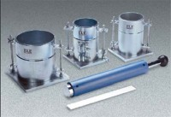 | Basic Laboratory Compaction Set, Hand-Operated  Code: 2300E  Attributes: Weight, lbs = 115.4, Description = Basic Laboratory Compaction Set, Hand-Operated  Standards: ASTM D698, ASTM D1557, AASHTO T99, AASHTO T180

