High Vacuum Pump
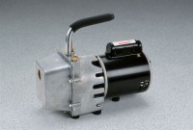 | High Vacuum Pump  Code: 88-3110/02  Attributes: Rated Power = 110vAC, 50/60 Hz, 1ø., Description = High Vacuum Pump  Standards:

 | High Vacuum Grease  Code: 88-3115  Attributes: Dimensions w x d x h, ” = 190x50x40 mm, Description = High Vacuum Grease  Standards:

Filtering Kit
Code: 45-9301
Attributes: Description = Filtering Kit
Standards:

