ELE Hand Auger
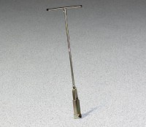 | ELE Hand Auger  Code: 23-1400  Attributes: Pins = Used to connect auger head to extension and<br>tee handle., Description = ELE Hand Auger  Standards:

 | 3-1/4" Auger Head  Code: 23-1400/10  Attributes: Weight, lbs = 3.52, Description = 3-1/4″ Auger Head  Standards:

Tee Handle
Code: 23-1400/11
Attributes: Weight, lbs = 2.03, Description = Tee Handle
Standards:

Auger Extensions 36"
Code: 23-1400/12
Attributes: Weight, lbs = 2.34, Description = Auger Extensions 36″
Standards:

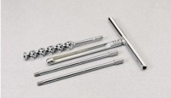 | Connector Pin  Code: 23-1400/13  Attributes: Weight, lbs = 0.22, Description = Connector Pin  Standards:

