Vibrating Tables
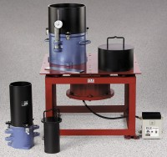 | Vibrating Table 60 Hz  Code: 24-9112/06  Attributes: Double Amplitude Range,” = 0.002 to 0.015, Description = Vibrating Table 60 Hz  Standards: ASTM D4253, ASTM D4254

Density Set 50 Hz
Code: 2500/01
Attributes: Rated Power = 220vAC, 50Hz, 1ø, Description = Density Set 50 Hz
Standards: ASTM D4253, ASTM D4254

Density Set 60 Hz
Code: 2500/06
Attributes: Rated Power = 220vAC, 60Hz, 1ø., Description = Density Set 60 Hz
Standards: ASTM D4253, ASTM D4254

 | Vibrating Table 50 Hz  Code: 24-9112/01  Attributes: Double Amplitude Range,” = 0.002 to 0.019, Description = Vibrating Table 50 Hz  Standards: ASTM D4253, ASTM D4254

