Pressure plate extractors
 | O-Ring Lid Seal Pack of 2  Code: 532-100/10  Attributes: Description = O-Ring Lid Seal  Standards:

1-Bar Pressure Plate Cell
Code: 532-104
Attributes: Description = 1-Bar Pressure Plate Cell
Standards:

3-Bar Pressure Plate Cell
Code: 532-106
Attributes: Description = 3-Bar Pressure Plate Cell
Standards:

5-Bar Pressure Plate Cell
Code: 532-107
Attributes: Description = 5-Bar Pressure Plate Cell
Standards:

Hose Manifold to 5 Bar Extractor.
Code: 532-111
Attributes: Description = Hose Manifold to 5 Bar Extractor
Standards:

Hose Manifold to 15 Bar Extractor.
Code: 532-112
Attributes: Description = Hose Manifold to 15 Bar Extractor
Standards:

Pm Compressor 220-240V 50Hz 1Ph.
Code: 532-180/01
Attributes: Description = Compressor
Standards:

Connection Set for 532-180 Series.
Code: 532-182
Attributes: Description = Connection Set
Standards:

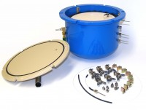 | 5-Bar Pressure Plate Extractor.  Code: 532-100  Attributes: Description = 5-Bar Pressure Plate Extractor  Standards:

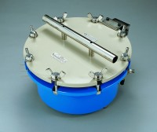 | 15-Bar Pressure Plate Extractor.  Code: 532-120  Attributes: Description = 15-Bar Pressure Plate Extractor  Standards:

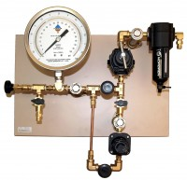 | Low Pressure Manifold  Code: 532-110  Attributes: Description = Low Pressure Manifold  Standards:

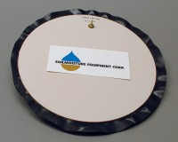 | 15-Bar Pressure Plate Cell.  Code: 532-120/10  Attributes: Description = 5-Bar Pressure Plate Cell  Standards:

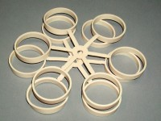 | Soil Sample Retaining Rings Pack of 12.  Code: 532-108  Attributes: Description = Soil Sample Retaining Rings  Standards:

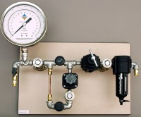 | Low to High Pressure Manifold Compression Type  Code: 532-128  Attributes: Description = Low to High Pressure Manifold  Standards:

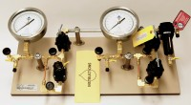 | Combination Manifold.  Code: 532-136  Attributes: Description = Combination Manifold  Standards:

