K-Slump Tester
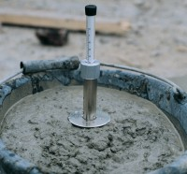 | K-slump Tester  Code: 34-0580  Attributes: Description = K-Slump Tester, Test Time, secs = 60, Weight, kg = 450 g  Standards:

