TDR
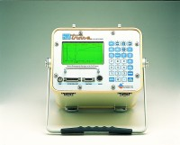 | Trase Soil Moisture Analyser  Code: 514-160/01  Attributes: Description = Trase Soil Moisture Analyser  Standards:

 | Wave Guide 150mm  Code: 514-160/10  Attributes: Description = Wave Guide 150 mm  Standards:

Wave Guides 300mm
Code: 514-162
Attributes: Description = Wave Guide 300 mm
Standards:

Wave Guides 600mm
Code: 514-164
Attributes: Description = Wave Guide 600 mm
Standards:

Wave Guides 700mm
Code: 514-165
Attributes: Description = Wave Guide 700 mm
Standards:

Alignment Block
Code: 514-169
Attributes: Description = Alignment Block
Standards:

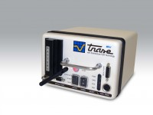 | Minitrase Kit with Bluetooth and Android  Code: 514-190/01  Attributes: Description = Minitrase Kit  Standards:

