Pneumatic Consolidation Apparatus
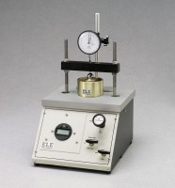 | Pneumatic Consolidation Apparatus  Code: 25-0560  Attributes: Required Air Pressure, psi = 123, Description = Pneumatic Consolidation Apparatus  Standards: ASTM D2435, ASTM D4546, AASHTO T216

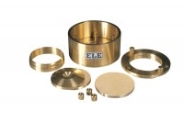 | Consolidation Cell Complete 50mm Diameter Sample.  Code: 25-0455  Attributes: Description = Consolidation cell 50 mm, Sample diameter = 50 mm, Stress for 1 kg, kPa = 50  Standards:

Consolidation Cell Complete 75mm Diameter Sample
Code: 25-0503
Attributes: Description = Consolidation cell 75 mm, Sample diameter = 75 mm, Stress for 1 kg, kPa = 20
Standards: BS 1377, EN 1997-2

Consolidation Cell Complete 2.5 Inch Diameter Sample. Inc. Porous Discs and Cutting Ring.
Code: 25-0479
Attributes: Description = Consolidation cell 2.5", Sample diameter = 2.5", Stress for 1 kg, lbf/ft²Stress for 1 kg, lbf/ft²Stress for 1 kg, lbf/ft²Stress for 1 kg, lbf/ft²Stre = 645
Standards: ASTM D2435, ASTM D4546, AASHTO T216

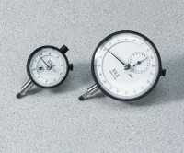 | Mechanical Dial Indicator - 0.4" Range  Code: 88-4070  Attributes: Dial Indicator = 0.4" Range, Description = Mechanical Dial Indicator - 0.4″ Range  Standards:

Mechanical Dial Indicator - 10 mm Range
Code: 88-4080
Attributes: Dial Indicator = 10 mm Range, Description = Mechanical Dial Indicator - 10 mm Range
Standards:

Mechanical Dial Indicator - 1.0" Range Counter Clockwise Movement
Code: 88-4120
Attributes: Dial Indicator = 1" Range, Description = Mechanical Dial Indicator - 1.0″ Range Counter Clockwise Movement
Standards:

Mechanical Dial Indicator - 25 mm Range Counter Clockwise Movement
Code: 88-4130
Attributes: Dial Indicator = 25 mm Range, Description = Mechanical Dial Indicator - 25 mm Range Counter Clockwise Movement
Standards:

2.416" Fixed Ring Consolidometer
Code: 25-0480
Attributes: Stress for 1 kg, lbf/ft²Stress for 1 kg, lbf/ft²Stress for 1 kg, lbf/ft²Stress for 1 kg, lbf/ft²Stre = 692, Description = 2.416″ Fixed Ring Consolidometer
Standards: ASTM D2435, ASTM D4546, AASHTO T216

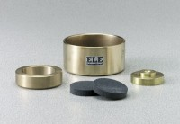 | 2.5" Floating Ring Consolidometer  Code: 25-0530  Attributes: Porous Stones dimensions diam x thick, ” = 2-15/32 x 1/2, Description = 2.5″ Floating Ring Consolidometer  Standards:

 | Electronic Digital Indicator, 0.600"/15 mm range  Code: 88-4210  Attributes: Dial Indicator = 0.6"/15 mm Range, Description = Electronic Digital Indicator, 0.600″/15 mm range  Standards:

Electronic Digital Indicator, 1.0"/25.4 mm range
Code: 88-4220
Attributes: Scale Divisions, tons/sq. Ft. = 0.0001" (0.002 mm), Description = Electronic Digital Indicator, 1.0″/25.4 mm range
Standards:

