Consolidation Apparatus
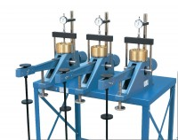 | Consolidation Frame One Dimensional Consolidation Incremental Loading Device.  Code: 25-0402  Attributes: Description = Consolidation frame, Loading Beam = Cast aluminum; counterbalanced; 9:1,10:1 and 11:1 ratios.  Standards: BS 1377, EN 1997-2, ASTM D2435, ASTM D4546, AASHTO T216

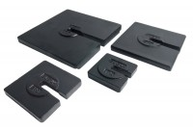 | Set of Weights 100Kg Total Weight.  Code: 25-0408  Attributes: Description = Set of weights, Weight, kg = 100  Standards: ASTM D2435, ASTM D4546, AASHTO T216

Floor Mounting Stand.
Code: 25-0429
Attributes: Description = Floor mounting stand, Table Dimensions, ” = 980mmx950mm
Standards: ASTM D2435, ASTM D4546, AASHTO T216

