C.O.E Cone Penetrometer
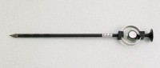 | C.O.E Cone Penetrometer  Code: 29-3741  Attributes: Shaft Dimensions, diam x l, ” = 5/8 x 19, Description = C.O.E Cone Penetrometer  Standards:

