Oil/Water Constant Pressure System
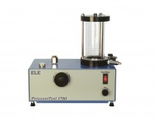 | Pressure Test 1700 Oil/Water Constant Pressure System 0 to 1700Kpa 220-240V 50/60Hz 1Ph.  Code: 26-1800/01  Attributes: Description = Pressure Test 1700 Oil/Water Constant Pressure System, Power Supply = 220 - 240 V AC, 50 - 60 Hz, 1 ph  Standards:

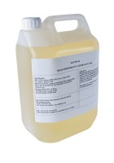 | Oil 5 Litres T46  Code: 26-1805  Attributes: Description = Oil 5 Litres T46  Standards:

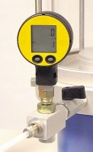 | Digital Pressure Gauge 1700Kpa. for Ele Triaxial Cells.  Code: 27-1620  Attributes: Description = Digital pressure gauge, Battery Life = 1400  Standards: ASTM D2850, ASTM D4767, ASTM D7181, ASTM D5084, AASHTO T296, AASHTO T297

