Sample Reduction
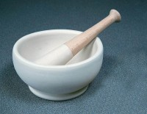 | Rubber Headed Pestle.  Code: 23-3500  Attributes: Description = Rubber Headed Pestle, Weight, kg = 0.12  Standards: BS 1377, BS 1924, ASTM D421, AASHTO T87

Mortar and Pestle Porcelain.
Code: 23-3505
Attributes: Description = Mortar and Pestle
Standards:

