General Expansion of Dry Hydrated Lime by the Le Chatelier Method
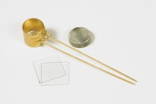 | Le Chatelier Mould  Code: 38-3005  Attributes: Description = Le Chatelier Mould, Weight, kg = 0.9  Standards: BS 6463, EN 196-3, EN 459-2

 | Extensibility of Mould Apparatus BS  Code: 38-3200  Attributes: Description = Extensibility of Mould Apparatus BS, Weight, kg = 0.1  Standards: EN 196-3

Extensibility of Mould Apparatus EN
Code: 38-3205
Attributes: Description = Extensibility of Mould Apparatus EN, Weight, kg = 0.3
Standards: EN 196-3

Tamping Rod
Code: 38-3300
Attributes: Description = Tamping Rod, Weight, kg = 0.07
Standards:

