Shrinkage Limit Set
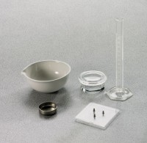 | Shrinkage Limit Set  Code: 2820E  Attributes: Weight, lbs = 1.07, Description = Shrinkage Limit Set  Standards: ASTM D427, AASHTO T92

