Flexural Testing for Beams
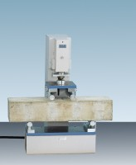 | 100kN Flexural (Beams) Frame. Supplied Without Specimen Bearers and Fitting Kit.  Code: 37-6130  Attributes: Description = 100kN Flexural (Beams) Frame  Standards:

 | BS 1881 Specimen Bearer Assembly 38mm Dia X 160mm Length.  Code: 37-6131  Attributes: Description = Specimen Bearers for flexural testing of beams EN  Standards:

ASTM C78 Specimen Bearer Assembly Case-Hardened 38mm Dia X 160mm Length.
Code: 37-6132
Attributes: Description = Specimen Bearers for flexural testing of beams ASTM
Standards:

Ball Seating Assembly 150mm Dia Platens.
Code: 37-6133
Attributes: Description = Ball Seating for testing low strength cubes up to 100 mm
Standards:

