Heavy-Duty Solution Balance
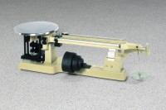 | Heavy-duty Solution Balance  Code: 78-7600  Attributes: Description = Heavy-duty Solution Balance, Attachment Weights = Slotted ratio type; one 1,000 g; two 2,000 g; one 5,000 g; one 10,000 g (included).  Standards:

