Volume Change Transducer
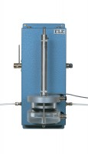 | Volume Change Transducer Assembly 80Cm3 Capacity Maximum Working Pressure 1700Kpa  Code: 27-1641  Attributes: Description = Volume change transducer assembly, Maximum Pressure, psi = 250  Standards:

