Flow and Workability of Mortar Lime
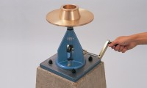 | Flow Table  Code: 38-6000  Attributes: Description = Flow Table, Weight, kg = 25  Standards: BS 4551-1, BS 3892-1, ASTM C230

 | Motorising Unit  Code: 38-6100/01  Attributes: Description = Motorising Unit, Power Supply = 220 - 240 V AC, 50 Hz, 1 ph  Standards: ASTM C230

Plastic Tamper
Code: 38-6160
Attributes: Description = Plastic Tamper
Standards: ASTM C230

Flow Mould
Code: 38-6040
Attributes: Description = Flow Mould
Standards: ASTM C230

ASTM Calipers
Code: 38-6080
Attributes: Description = ASTM Calipers
Standards: ASTM C230

