Round Bottom Scoops
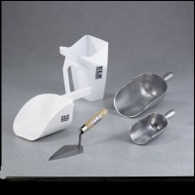 | Round Bottom Scoop 1/2 qt. Capacity  Code: 88-7300  Attributes: Description = Round Bottom Scoop 1/2 qt. Capacity  Standards:

Round Bottom Scoop 1 qt. Capacity
Code: 88-7302
Attributes: Construction = Aluminum, Description = Round Bottom Scoop 1 qt. Capacity
Standards:

