Moulding of Prisms
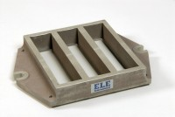 | Feeding Hopper  Code: 39-1120  Attributes: Description = Feeding Hopper  Standards:

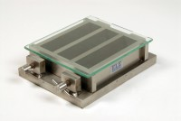 | Three-gang Mould  Code: 39-1100  Attributes: Description = Three-gang Mould, Weight, kg = 12.2  Standards:

 | Glass Plate.  Code: 24-0430  Attributes: Description = Glass plate, BS/EN Standard = Yes  Standards: BS 1377, EN 1997-2

Scraper
Code: 39-1130
Attributes: Description = Scraper
Standards:

Mortar Sand
Code: 39-1170
Attributes: Description = Mortar Sand
Standards: EN 196-1, EN 413-2, EN 459-2, EN 1744-1, EN 1015-10, EN 1015-11, EN 13454-2, ISO 679, BS 3892-1, BS 4551-1

