Bitumen Extraction Test
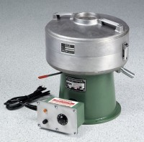 | Centrifuge Extractor 1,500 g  Code: 45-3820/02  Attributes: Description = Centrifuge Extractor 1,500 g  Standards: ASTM D2172, AASHTO T164

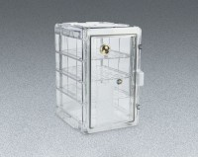 | Desiccator Cabinet  Code: 88-6700  Attributes: Description = Desiccator Cabinet  Standards:

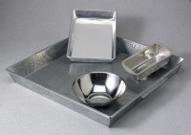 | Pan, Galvanized  Code: 88-7150  Attributes: Description = Pan, Galvanized  Standards:

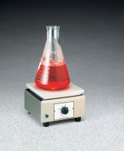 | Hot Plate  Code: 88-0500/02  Attributes: Description = Hot Plate 39 sq. in.  Standards:

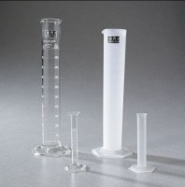 | Graduated Cylinder  Code: 88-6012  Attributes: Description = Glass Graduated Cylinder - 1 Litre Capacity  Standards:

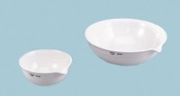 | Evaporating Dish - 250 ml Capacity  Code: 88-6712  Attributes: Description = Evaporating Dish - 250 ml Capacity  Standards:

