Plastic Dispensing Bottles
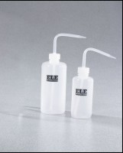 | Plastic Dispensing Bottle - 250 ml Capacity  Code: 88-6610  Attributes: Liquid Capacity, ml = 250, Description = Plastic Dispensing Bottle - 250 ml Capacity  Standards:

Plastic Dispensing Bottle - 500 ml Capacity
Code: 88-6612
Attributes: Liquid Capacity, ml = 500, Description = Plastic Dispensing Bottle - 500 ml Capacity
Standards:

