Measuring Equipment
 | Drying Shrinkage & Moisture Movement Apparatus Complete with Two Calibration Rods  Code: 34-8500  Attributes: Description = Drying Shrinkage & Moisture Movement Apparatus, Weight, kg = 4.5  Standards:

Length Comparator 11 5/8in Total Length; 3/8in Dia Tips.
Code: 34-8505/10
Attributes: Description = Spare length comparator
Standards:

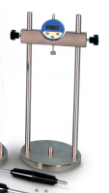 | Length Comparator  Code: SP34-8501  Attributes: Description = Length Comparator  Standards: ASTM C348, ASTM C490, EN 12617-4, EN 12808-4

