Sand Grading Chart
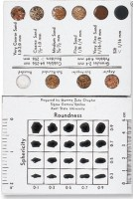 | Sand Grading Chart  Code: 23-7130  Attributes: Particle Panels = Angular; sub-angular; sub-rounded and rounded., Description = Sand Grading Chart  Standards:

