ASR Detect Alkali Silica Reaction (ASR) Kit
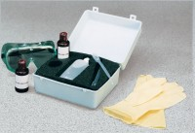 | ASR Detect  Code: 35-2170  Attributes: Weight, lbs = 5, Description = ASR Detect  Standards:

