Laboratory Vane Apparatus
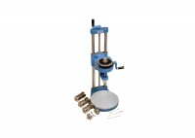 | Laboratory Vane Apparatus with 4 Springs and 12.7mm Vane; Hand Operated.  Code: 26-2270  Attributes: Description = Laboratory Vane Apparatus, Weight, kg = 7.5  Standards: BS 1377

 | Set of 4 Calibrated Springs for Laboratory Vane Apparatus.  Code: 26-2275/10  Attributes: Description = Set of 4 calibrated springs (spare)  Standards: BS 1377

Vane 12.7mm Diameter X 12.7mm Long.
Code: 26-2279
Attributes: Description = Vane 12.7 mm x 12.7 mm long
Standards: BS 1377

Vane 12.7mm Diameter X 19mm Long
Code: 26-2281
Attributes: Description = Vane 12.7 mm dia X 19 mm long
Standards: BS 1377

Vane 12.7mm Diameter X 25.4mm Long.
Code: 26-2283
Attributes: Description = Vane 12.7 mm dia x 25.4mm long
Standards: BS 1377

