Mechanical Balances
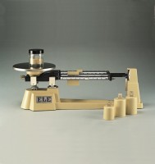 | Triple Beam Balance  Code: 78-7140  Attributes: Description = Triple Beam Balance, Weight, lbs = 8  Standards:

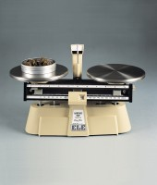 | Harvard Trip Balance  Code: 78-7090  Attributes: Description = Harvard Trip Balance, Specific Gravity = Equipped for specific gravity weighing (components not included, order separately)  Standards:

 | Weights for Harvard Trip Balance  Code: 78-7110  Attributes: Description = Weights for Harvard Trip Balance  Standards: ASTM class 6

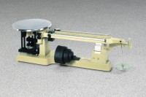 | Heavy-duty Solution Balance  Code: 78-7600  Attributes: Description = Heavy-duty Solution Balance, Attachment Weights = Slotted ratio type; one 1,000 g; two 2,000 g; one 5,000 g; one 10,000 g (included).  Standards:

