Cement Cube Mould (Economy)
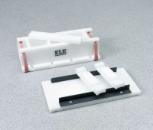 | Cement Cube Mould - Economy  Code: 39-0416  Attributes: Top, ” = Polyethylene with plastic guide rails., Description = Cement Cube Mould - Economy  Standards:

