Automatic Vicat
 | Needle Cleaning Device  Code: 38-2015/12  Attributes: Description = Needle Cleaning Device  Standards: ASTM C187, ASTM C191

Printer Paper Rolls
Code: 38-2015/14
Attributes: Description = Printer Paper Rolls
Standards: ASTM C187, ASTM C191

Mould Tank
Code: 38-2015/15
Attributes: Description = Mould Tank
Standards: ASTM C187, ASTM C191

Consistency Plunger
Code: 38-2015/16
Attributes: Description = Consistency Plunger
Standards: ASTM C187, ASTM C191

EN Initial and Final Set Needle
Code: 38-2021
Attributes: Description = EN Initial and Final Set Needle
Standards: ASTM C187, ASTM C191

ASTM Initial and Final Set Needle
Code: 38-2023
Attributes: Description = ASTM Initial and Final Set Needle
Standards: ASTM C187, ASTM C191

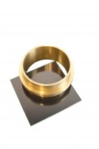 | Vicat Mould  Code: 38-2200  Attributes: Description = Vicat Mould  Standards: ASTM C187, ASTM C191

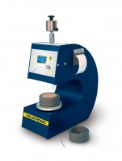 | Automatic Vicat Apparatus  Code: 38-2015/01  Attributes: Description = Automatic Vicat Apparatus (includes Needle Sets and Moulds for EN and ASTM), Power Supply = 220 - 240 V AC, 50 - 60 Hz, 1 ph  Standards: ASTM C187, ASTM C191

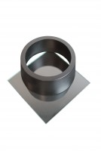 | EN Vicat Mould  Code: 38-2300  Attributes: Description = EN Vicat Mould  Standards: EN 196-3

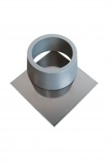 | ASTM Vicat Mould  Code: 38-2660  Attributes: Description = ASTM Vicat Mould  Standards: ASTM C187, ASTM C191

