Automatic data acquisition
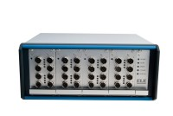 | GDU 8 Channel Data Acquisition Unit 220-240 V 50/60 Hz, 1 Ph.  Code: 27-1500/01  Attributes: Description = GDU 8 channel data acquisition unit, Transducer Supply = 10vDC., Voltage Supply = 220-240 V 50/60 Hz  Standards:

 | DS7.1 One-Dimensional Consolidation Software  Code: 27-1770  Attributes: Weight, lbs = 1.1, Description = DS7.1 One-Dimensional Consolidation Software  Standards: ASTM D2435, ASTM D4546, AASHTO T216, BS 1377, EN 1997-2

